

Foundations of Programming

Assignment No.: 17
PROBLEM STATEMENT: To accept the number of terms and find the sum of the sine series.

OBJECTIVE:

- To understand the concept of mathematical series in programming.
- To implement sine series using C programming.
- To practice loops and arithmetic operations.
- To learn the use of factorial and power calculations in C.

THEORY:
In mathematics, the sine function can be expressed as an infinite series called the Taylor series expansion. The sine series is represented as:
sin(x) = x − x^3/3! + x^5/5! − x^7/7! + ...

In this program, the user enters the value of x and the number of terms. The program calculates the sum of the sine series up to the specified number of terms using loops. Factorial and power operations are used to compute each term of the series.
PLATFORM: Linux
CODE:
#include <stdio.h>

int main() {
int n;
double x, term, sum = 0.0;

// Accept inputs from the user
printf("Enter the value of x (in radians): ");
scanf("%lf", &x);
printf("Enter the number of terms: ");
scanf("%d", &n);

// The first term in the series is always x
term = x;

// Loop to calculate and add each term
for (int i = 1; i <= n; i++) {
sum += term;
// Derive the next term from the current term to avoid calculating huge factorials
term = -term * x * x / ((2 * i) * (2 * i + 1));
}

printf("The sum of the sine series up to %d terms is: %.6lf\n", n, sum);

return 0;
}

INPUT AND OUTPUT:
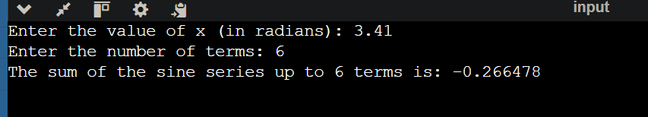

CONCLUSION: Thus, the C program successfully calculates the sum of the sine series for the given number of terms.

